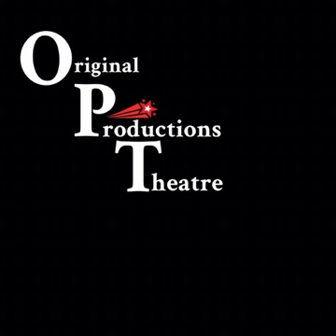 AUDITION FORM

Name: __________________________________________________________________

Email: __________________________________________________________________

Phone: _________________________________________________________________

Desired Role: ____________________________________________________________

Will you accept a role aside from your desired role? Yes _____ No _____

Conflicts: ________________________________________________________________________________________________________________________________________________________________________________________________________________________

Anything else you’d like us to know about yourself: ________________________________________________________________________________________________________________________________________________________________________________________________________________________________________________________________________________________________________________________________________________________________________________________________________________________________________________________________________________________________________________________

Please provide a headshot and resume, if available, for our records.

